# [The Battle of Neighbourhoods in Amsterdam](https://eu-gb.dataplatform.cloud.ibm.com/projects/f76e96e4-95f8-4da0-a6c1-31fa7471c9c8?context=analytics" \o "The Battle of Neighborhoods in Amsterdam)

Praveen Kumar Vishnumolakala

September 1st, 2019

## 1. Introduction

## 1.1 Background

Amsterdam is the [capital](https://en.wikipedia.org/wiki/Capital_of_the_Netherlands) and [most populous city](https://en.wikipedia.org/wiki/List_of_municipalities_of_the_Netherlands) of the [Netherlands](https://en.wikipedia.org/wiki/Netherlands), with a population of 866,737 within the city proper, 1,380,872 in the [urban area](https://en.wikipedia.org/wiki/City_Region_of_Amsterdam) and 2,410,960 in the [metropolitan area](https://en.wikipedia.org/wiki/Amsterdam_metropolitan_area). Amsterdam is in the [province](https://en.wikipedia.org/wiki/Provinces_of_the_Netherlands) of [North Holland](https://en.wikipedia.org/wiki/North_Holland).

Amsterdam's name derives from Amstelredamme indicative of the city's origin around a dam in the river [Amstel](https://en.wikipedia.org/wiki/Amstel). Originating as a small fishing village in the late 12th century, Amsterdam became one of the most important ports in the world in the [Dutch Golden Age](https://en.wikipedia.org/wiki/Dutch_Golden_Age) of the 17th century and became the leading centre for finance and trade. In the 19th and 20th centuries, the city expanded, and many new neighbourhoods and suburbs were planned and built. The 17th-century [canals of Amsterdam](https://en.wikipedia.org/wiki/Canals_of_Amsterdam) and the 19–20th century [Defence Line of Amsterdam](https://en.wikipedia.org/wiki/Stelling_van_Amsterdam) are on the [UNESCO World Heritage List](https://en.wikipedia.org/wiki/World_Heritage_Site). [Sloten](https://en.wikipedia.org/wiki/Sloten,_Amsterdam" \o "Sloten, Amsterdam), annexed in 1921 by the municipality of Amsterdam, is the oldest part of the city, dating to the 9th century.

As the commercial capital of the Netherlands and one of the top financial centres in Europe, Amsterdam is considered an [alpha- world city](https://en.wikipedia.org/wiki/Global_city) by the [Globalization and World Cities](https://en.wikipedia.org/wiki/Globalization_and_World_Cities_Research_Network) (GaWC) study group. The city is also the cultural capital of the Netherlands. Many large Dutch institutions have their headquarters there, including [Philips](https://en.wikipedia.org/wiki/Philips), [AkzoNobel](https://en.wikipedia.org/wiki/AkzoNobel), [TomTom](https://en.wikipedia.org/wiki/TomTom) and [ING](https://en.wikipedia.org/wiki/ING_Group). Also, many of the world's largest companies are based in Amsterdam or established their European headquarters in the city, such as leading technology companies [Uber](https://en.wikipedia.org/wiki/Uber), [Netflix](https://en.wikipedia.org/wiki/Netflix) and [Tesla](https://en.wikipedia.org/wiki/Tesla,_Inc.). In 2012, Amsterdam was ranked the second best city to live in by the [Economist Intelligence Unit](https://en.wikipedia.org/wiki/Economist_Intelligence_Unit) (EIU) and 12th globally on quality of living for environment and infrastructure by Mercer. The city was ranked 4th place globally as top tech hub in the Savills Tech Cities 2019 report (2nd in Europe), and 3rd in innovation by Australian innovation agency 2thinknow in their Innovation Cities Index 2009. The [Port of Amsterdam](https://en.wikipedia.org/wiki/Port_of_Amsterdam) is the fifth largest in Europe. Famous Amsterdam residents include the diarist [Anne Frank](https://en.wikipedia.org/wiki/Anne_Frank), artists [Rembrandt](https://en.wikipedia.org/wiki/Rembrandt) and [Van Gogh](https://en.wikipedia.org/wiki/Vincent_van_Gogh), and philosopher [Baruch Spinoza](https://en.wikipedia.org/wiki/Baruch_Spinoza).

The [Amsterdam Stock Exchange](https://en.wikipedia.org/wiki/Amsterdam_Stock_Exchange) is the oldest stock exchange in the world. [Amsterdam's main attractions](https://en.wikipedia.org/wiki/List_of_tourist_attractions_in_Amsterdam) include its [historic canals](https://en.wikipedia.org/wiki/Canals_of_Amsterdam), the [Rijksmuseum](https://en.wikipedia.org/wiki/Rijksmuseum), the [Van Gogh Museum](https://en.wikipedia.org/wiki/Van_Gogh_Museum), the [Stedelijk Museum](https://en.wikipedia.org/wiki/Stedelijk_Museum_Amsterdam" \o "Stedelijk Museum Amsterdam), [Hermitage Amsterdam](https://en.wikipedia.org/wiki/Hermitage_Amsterdam), the [Anne Frank House](https://en.wikipedia.org/wiki/Anne_Frank_House), the [Scheepvaartmuseum](https://en.wikipedia.org/wiki/Nederlands_Scheepvaartmuseum" \o "Nederlands Scheepvaartmuseum), the [Amsterdam Museum](https://en.wikipedia.org/wiki/Amsterdam_Museum), the [Heineken Experience](https://en.wikipedia.org/wiki/Heineken_Experience), the [Royal Palace of Amsterdam](https://en.wikipedia.org/wiki/Royal_Palace_of_Amsterdam), [Natura Artis Magistra](https://en.wikipedia.org/wiki/Natura_Artis_Magistra" \o "Natura Artis Magistra), [Hortus Botanicus Amsterdam](https://en.wikipedia.org/wiki/Hortus_Botanicus_Amsterdam" \o "Hortus Botanicus Amsterdam), [NEMO](https://en.wikipedia.org/wiki/NEMO_(museum)), the [red-light district](https://en.wikipedia.org/wiki/Red-light_district) and many [cannabis coffee shops](https://en.wikipedia.org/wiki/Coffeeshop_(Netherlands)). They draw more than 5 million international visitors annually. The city is also well known for its nightlife and festival activity; several of its nightclubs ([Melkweg](https://en.wikipedia.org/wiki/Melkweg" \o "Melkweg), [Paradiso](https://en.wikipedia.org/wiki/Paradiso_(Amsterdam)" \o "Paradiso (Amsterdam))) are among the world's most famous. It is also one of the world's most multicultural cities, with at least 177 nationalities represented.

## 1.2 Problem

In Amsterdam, There are many shops, office, entertainments etc. Amsterdam municipality distubute there funds to all areas to develop more .Now, Amsterdam municipality want to cluster all similar areas(In postal code point of view). So, there maintain all areas in same standards in the Amsterdam municipality areas to increase tourism in the all the Amsterdam.

## 1.3 Interest

Amsterdam municipality also want know total number venues in the total Amsterdam area in the venue categories.

## 2. Data acquisition and cleaning

## 2.1 Data sources

In wiki, we have postal code with geo coordinates.

By using [https://foursquare.com](https://foursquare.com/), we retrieved all the venues details in Amsterdam with geo co-ordinates.

## 2.2 Data cleaning

Data download and loaded into IBM Watson page.

Read data from streaming_body_4 and convert the same to python data frame and set index to postal code.

Using [https://foursquare.com](https://foursquare.com/) , retrieve all venues details from coordinates.

We will get venues details in json format. So, retrieve all venues details as below:

## 2.3 Feature selection

After data cleaning, there 3048 venues and 200 postal codes. Upon examining the meaning of each feature, it was clear that there was some redundancy in the features.

I am going to select below fileds as feature selection :

| **Venue Id** | **Venue** | **Venue Latitude** | **Venue Longitude** | **Venue Category** |
| --- | --- | --- | --- | --- |

## 3. Exploratory Data Analysis

Based on data retrieved from foursquare, below are top venues in the Amsterdam.

Albert Heijn 41

HEMA 16

Bagels & Beans 14

Starbucks 13

Lidl 12

Coffee Company 10

Action 9

Blokker 8

Febo 8

Marqt 8

Jumbo 7

Etos 7

Kruidvat 7

IJscuypje 7

Dirk van den Broek 6

Primera 6

STACH food 5

H&M 5

SLA 5

Spoor 2 4

BCC 4

Wok to Walk 4

Vegan Junk Food Bar 4

Le Pain Quotidien 4

ALDI 4

EkoPlaza 4

And below top venues categories in Amsterdam:

Restaurant 134

Café 124

Hotel 121

Bar 121

Coffee Shop 121

Supermarket 87

Italian Restaurant 83

Bakery 73

Bus Stop 52

Plaza 46

Pizza Place 43

Breakfast Spot 41

Park 41

Snack Place 41

French Restaurant 38

Chinese Restaurant 38

Sandwich Place 38

Gym / Fitness Center 38

Tram Station 33

Gym 31

Marijuana Dispensary 30

Turkish Restaurant 29

Clothing Store 29

Ice Cream Shop 28

Grocery Store 27

Asian Restaurant 27

Thai Restaurant 27

Burger Joint 25

Furniture / Home Store 24

Gastropub 24

## 4. Clustering

End goal is to cluster the all the areas into groups.

To do, First, I am identifying what all different types of venues do we have Amsterdam and give the score for the same by Neighborhood.

Get scores, by top 20 venues from Neighborhood as below:

----1011 DG----

venue freq

0 Restaurant 0.13

1 Hotel 0.09

2 Hostel 0.07

3 Hotel Bar 0.06

4 Bar 0.06

5 Lounge 0.04

6 Italian Restaurant 0.04

7 Boat or Ferry 0.04

8 Modern European Restaurant 0.02

9 Science Museum 0.02

10 Harbor / Marina 0.02

11 Bed & Breakfast 0.02

12 Beer Bar 0.02

13 Gastropub 0.02

14 Climbing Gym 0.02

15 Supermarket 0.02

16 Sandwich Place 0.02

17 Concert Hall 0.02

18 Performing Arts Venue 0.02

19 Scenic Lookout 0.02

----1011 DL----

venue freq

0 Café 1.0

1 Zoo Exhibit 0.0

2 Opera House 0.0

3 Palace 0.0

4 Outdoors & Recreation 0.0

5 Outdoor Supply Store 0.0

6 Outdoor Sculpture 0.0

7 Organic Grocery 0.0

8 Optical Shop 0.0

9 Office 0.0

10 Park 0.0

11 North Indian Restaurant 0.0

12 Nightclub 0.0

13 Nail Salon 0.0

14 Music Venue 0.0

15 Music Store 0.0

16 Music School 0.0

17 Museum 0.0

18 Paper / Office Supplies Store 0.0

19 Parking 0.0

----1011 HB----

venue freq

0 Hotel 0.10

1 Thai Restaurant 0.10

2 Ice Cream Shop 0.05

3 Candy Store 0.05

4 Theater 0.05

5 Steakhouse 0.05

6 South American Restaurant 0.05

7 Smoke Shop 0.05

8 Café 0.05

9 Chinese Restaurant 0.05

10 Bagel Shop 0.05

11 Deli / Bodega 0.05

12 Design Studio 0.05

13 Fish Market 0.05

14 Opera House 0.05

15 Grocery Store 0.05

16 Indie Theater 0.05

17 Bar 0.05

18 Italian Restaurant 0.05

19 Tibetan Restaurant 0.00

Create most common venues for each and every Neighborhood as below:

| **Neighborhood** | **1st Most Common Venue** | **2nd Most Common Venue** | **3rd Most Common Venue** | **4th Most Common Venue** | **5th Most Common Venue** | **6th Most Common Venue** | **7th Most Common Venue** | **8th Most Common Venue** | **9th Most Common Venue** | **10th Most Common Venue** |
| --- | --- | --- | --- | --- | --- | --- | --- | --- | --- | --- |
| **0** | 1011 DG | Restaurant | Hotel | Hostel | Bar | Hotel Bar | Boat or Ferry | Lounge | Italian Restaurant | Scenic Lookout | Bike Rental / Bike Share |
| **1** | 1011 DL | Café | Farm | Electronics Store | Empanada Restaurant | Ethiopian Restaurant | Event Space | Exhibit | Fabric Shop | Falafel Restaurant | Zoo |
| **2** | 1011 HB | Hotel | Thai Restaurant | Ice Cream Shop | Italian Restaurant | Candy Store | Bar | Steakhouse | Bagel Shop | Theater | Chinese Restaurant |
| **3** | 1011 JH | Marijuana Dispensary | Hotel | Restaurant | Italian Restaurant | Gay Bar | Nightclub | Sandwich Place | Coffee Shop | Pastry Shop | Organic Grocery |
| **4** | 1011 KW | Hotel | Gastropub | Bridge | Sandwich Place | French Restaurant | Mexican Restaurant | Greek Restaurant | Beer Bar | Bar | Marijuana Dispensary |

Based on scores, iterating more and more time. I am planned to make 30 clusters.

And I got results as below:

array([ 6, 24, 18, 18, 26, 26, 18, 26, 8, 26, 6, 0, 6, 6, 18, 18, 26,

18, 26, 18, 26, 6, 7, 6, 28, 26, 0, 6, 13, 0], dtype=int32)

Here sample for the same:

| **latitude** | **longitude** | **Postal Code** | **Cluster Labels** | **1st Most Common Venue** | **2nd Most Common Venue** | **3rd Most Common Venue** | **4th Most Common Venue** | **5th Most Common Venue** | **6th Most Common Venue** | **7th Most Common Venue** | **8th Most Common Venue** | **9th Most Common Venue** | **10th Most Common Venue** |
| --- | --- | --- | --- | --- | --- | --- | --- | --- | --- | --- | --- | --- | --- |
| **0** | 52.293 | 4.980 | 1107 | 18 | Pharmacy | Drugstore | Snack Place | Farm | Empanada Restaurant | Ethiopian Restaurant | Event Space | Exhibit | Fabric Shop | Falafel Restaurant |
| **2** | 52.298 | 4.956 | 1105 | 11 | Restaurant | Zoo | Dutch Restaurant | Electronics Store | Empanada Restaurant | Ethiopian Restaurant | Event Space | Exhibit | Fabric Shop | Falafel Restaurant |
| **3** | 52.298 | 4.958 | 1105 AW | 18 | Coffee Shop | Convenience Store | Italian Restaurant | Snack Place | Shopping Mall | Science Museum | Grocery Store | Sandwich Place | Pizza Place | Dance Studio |
| **4** | 52.299 | 4.956 | 1105 BM | 18 | Fast Food Restaurant | Coffee Shop | Chinese Restaurant | Pharmacy | Metro Station | Electronics Store | Platform | Fish & Chips Shop | Fish Market | Field |

And neighbourhood in Amsterdam looks as below:

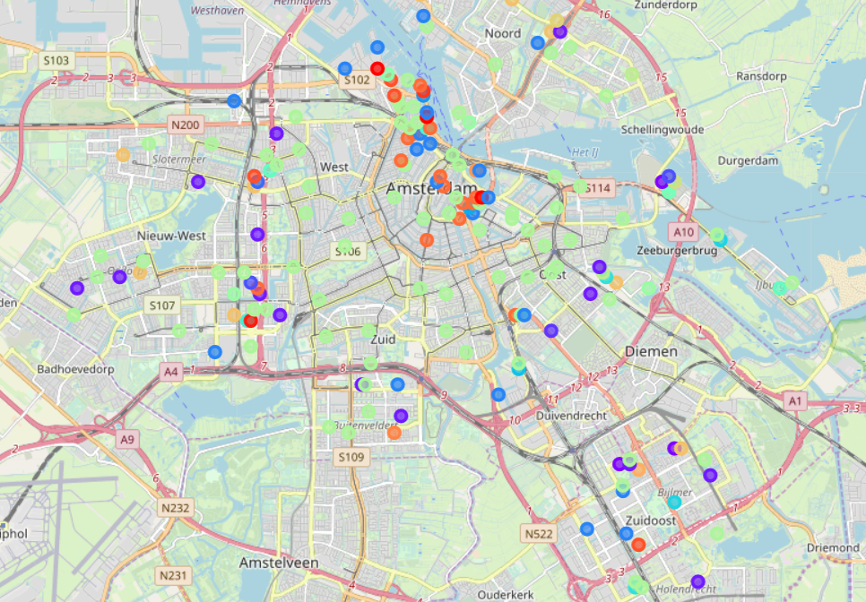

## 5. Conclusions

In this study, I analysed that all around more centre to Amsterdam same characteristics and out-cuts Amsterdam having simpler characteristics. In the Amsterdam Zuidoost side all it’s more same as Amsterdam Center.

So Amsterdam municipality, Need to focus on more out-cuts and some east-side of Amsterdam.

## 6. Future directions

Now, Amsterdam municipality will focus on conclude areas. After the focused this area they want to do same study once again. More options to venues to establish on the less populate areas. So they can increase the revenue on tourism.